COVID -19

All staff are to wash hands when entering a room with water and soap and use alcohol hand rub provided throughout the day. It is staffs responsibility to ensure ALL children are washing their hands throughout the day
Staff are to self isolate for 14 days if they show any of the following;
- they have coronavirus
- they have coronavirus symptoms, for example a high temperature or new continuous cough
- someone in their household has coronavirus symptoms • they've been told to self-isolate by a doctor or NHS 111.
It is staffs responsibility to alert management of any new symptoms regarding coronavirus and be prepared to be sent home and in self isolation if management see fit.
It is staffs responsibility to monitor children’s health and report to management if they notice any children with symptoms of coronavirus The symptoms of coronavirus are:
- a high temperature – this means you feel hot to touch on your chest or back (you do not need to measure your temperature)
- a new, continuous cough – this means coughing a lot for more than an hour, or 3 or more coughing episodes in 24 hours (if you usually have a cough, it may be worse than usual)
- a loss or change to your sense of smell or taste – this means you've noticed you cannot smell or taste anything, or things smell or taste different to normal

Any parent noticing signs or symptoms of a persistent cough of their child attending nursery, or anyone within the household HAS to follow government guidelines and keep them quarantined for the 14 days. If staff notice these symptoms in nursery, following the DFE requirements children will be expected to be collected immediately also following the 14 day isolation. Management will inform parents on which date the child is allowed back into nursery.

At Spring Grove Nursery we will follow the guidelines given to us by the NDNA, these are as follows.
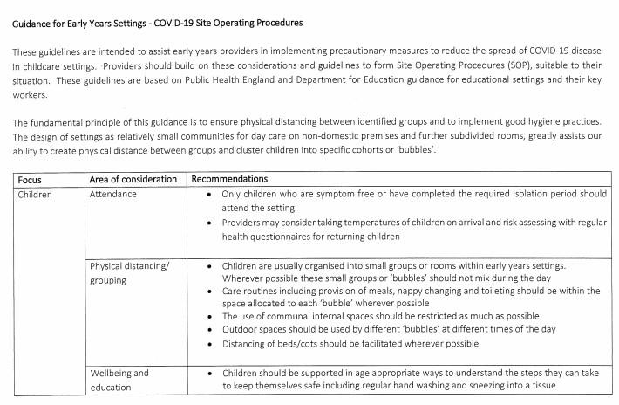

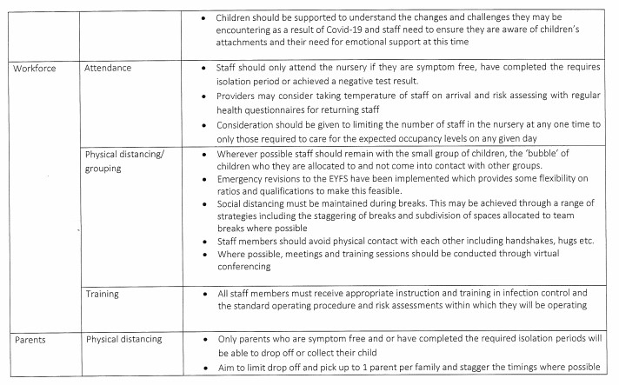

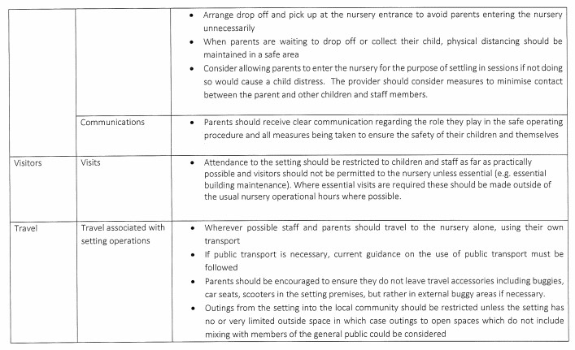
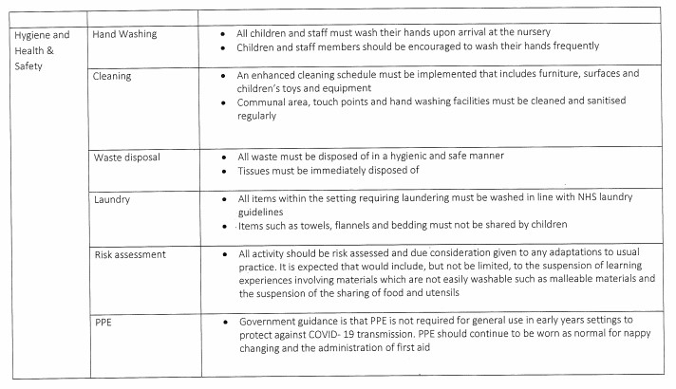
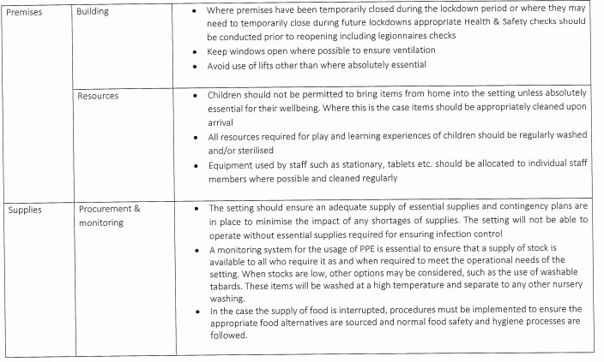
The identified room in which isolation will happen until a child can be collected is the nursery staff room, where appropriate PPE (Gloves, Apron and face mask) will be provided if a staff member needs to accompany those if their waiting to be collected.

Every hour within the rooms, staff are to use antibacterial spray and wipe down all surfaces, door handles and light switches. The staff are to clean over toys at times when they are not in use, such as meal times and sleep times before deep cleaning them each evening. The rooms get a deep clean each evening with appropriate cleaning equipment once all children have left the building.

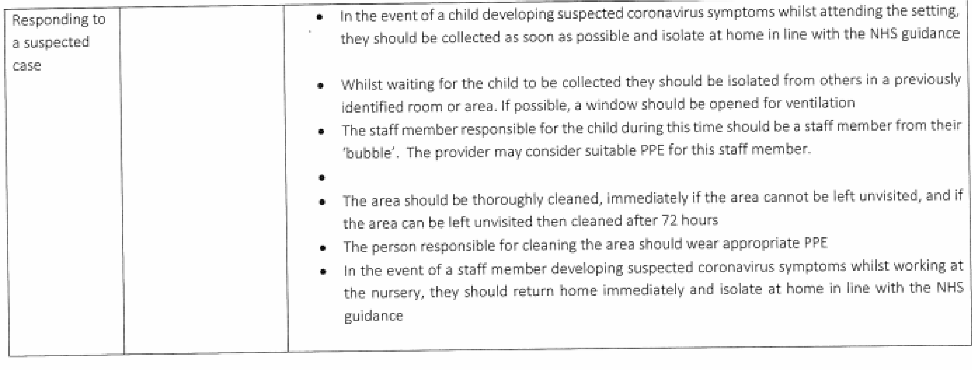
When collecting their child, parents are to call the nursery approximately 5 minutes before arriving so we can ensure that they are ready at the door to minimise the amount of time parents are waiting, eliminating back log of parents.

Management risk assess daily the surroundings and ensure the cleaning is maintained and that staff adhere to the bubbles for their age group.

Parents understand their own responsibility when sending their child back to nursery and when they do so they agree and understand the responsibility of being completely honest with management if someone in their house hold, or someone they or their child has come in contact with needs to isolate, as this in turn means they have to follow the guidelines given by government (please see higher within the policy if you are unsure of what these are).

